Learn to create your own​ Vox Pop​
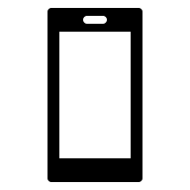
Workshop series 2

Film and edit on your mobile phone or tablet/iPad
(Editing means taking what you have filmed and putting it together in a video that can be shared)
Download the VN Editor APP​

Workshop Goals:

Part 1:
- What is a vox pop?
- Choose your question
- Ask people the question and get their answer (this is called an interview). Film it.
Part 2:
- Learn how to edit your vox pop

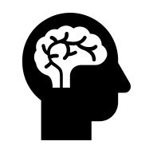
Remember:

- It is okay if you feel unsure about things. You are here to learn!
- Your vox pop does not need to be perfect. Keep it real!
- Have fun with it!

Vox pops:

- 1 clear question
- Real people, real answers
- Short and to the point

Planning your vox pop:

- Topics can be light or serious

- Pick a question that actually interests you

- Ask a question that cannot be answered with just ‘yes’ or ‘no’ (this is called an open-ended question)
- Keep the question simple
- Let them talk. Stay quiet while they answer.
Some good questions could be:

- What makes you feel comfortable?
- What is something you are grateful for?​
- If you could give your 11-year-old-self one piece of advice, what would it be?​
- What is something that you have changed your mind about?
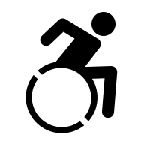
- What is something you have changed your mind about when it comes to disability?


- What is something you feel people get wrong about disability?
- What comes to mind when you hear the word ‘inspiring’?
- What is the most creative way you have solved a problem?

Use open-ended questions

    - Closed question: Do you feel confident?
    - Open-ended question: What makes you feel confident?

Let’s think about vox pops:
- Who​
- How​
- When​
- Why​
- Tell me about…
Filming with a mobile phone:
- 1 meter away
- How is the sound?
- Face lighter than background
- Rule of thirds
- Ask if it is okay


People skills:
- Tell them who you are
- Ask if it is okay for you to film them
- Be calm and treat them with respect
- If they are nervous, warm them up with an easy question
- Make sure they stay in frame

Vox Pop intro and outro
- Tell viewers what it is about
- Leave viewers with something to think about

Why does the intro and outro matter?
- You can add text to your vox pop to give people more information
- If you are not adding text then you will need to talk about it instead

What tools can we use to make vox pops?

