


South Australian Election – March 2026

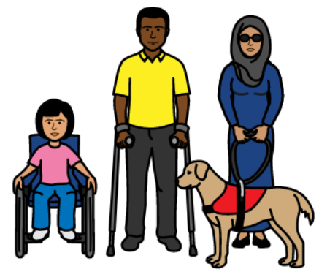
Make things better for people with disability


Easy English

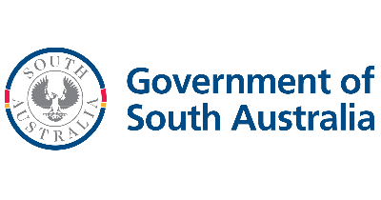
The South Australian Government are a group of people who lead South Australia.
South Australia will be called SA in this book.


They make important choices.

The SA Government should help people with disability.

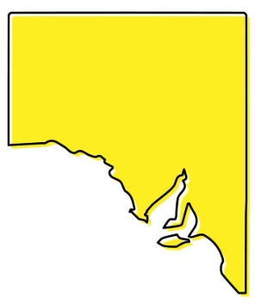
There will be another election in SA.
An election is when everyone votes for the people they want in the Government.


The election will be in March 2026.

Many different groups will be asking for your vote.


These groups should do good for people with disability.
People with disability should be included in the community.

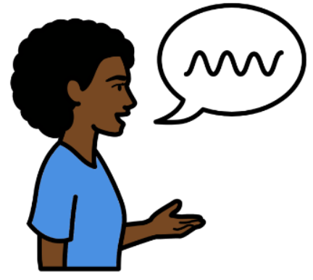
We want these groups to tell us how they will help people with disability.

How can the SA Government help people with disability?

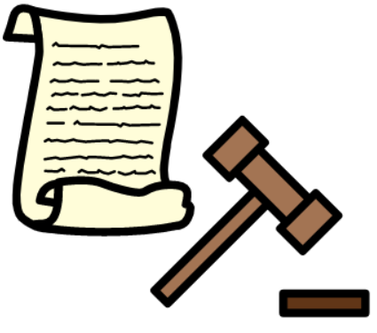
Advocacy
Advocacy services stand up for the rights of people with disability.


They stop people with disability from getting hurt.

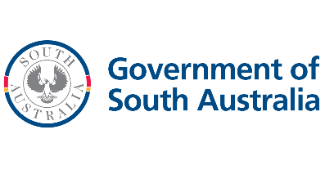
The SA Government should help pay for these services.


Will the SA Government pay for advocacy services for people with disability?
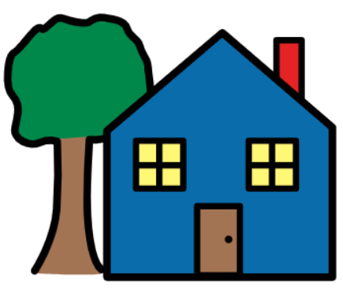
Housing
People with disability need a good house.

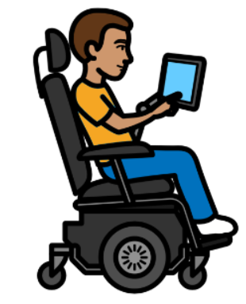
They need a house that meets their needs.

Will the SA Government make laws better so people with disability can get good housing?

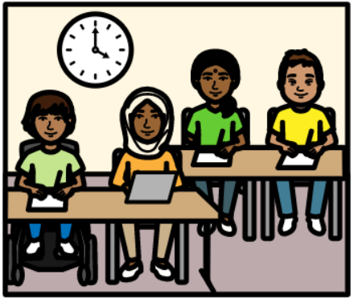
Education
Education needs to be more inclusive.

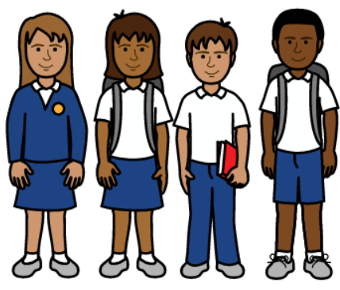
This will help all children and teenagers.

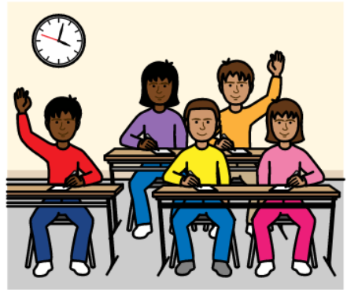
Will the SA Government make education more inclusive?

