
Workshop Series 3:
Getting started on LinkedIn (Part 1)
(Plain English)

Welcome
- Today’s session will be recorded
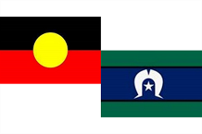
- Acknowledgement of Country
- Disability community

- We will talk about some general things like: mute/unmute, raise your hand to speak, use the chat

Introduction

- Meet the team:​
- Marissa Brown will be presenting
- Nick Roach and Mel Merlino will be helping
- Lee will be doing the live captions
- Introduce yourself in the chat


What will we talk about today?

- What is LinkedIn?​
- Building your LinkedIn profile.​

- Staying safe on LinkedIn.​
- Using LinkedIn.​

- Finding opportunities.​

Next session (30 Jan): Get your ​professional photo taken
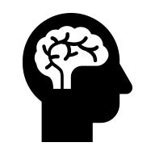
What will you learn?
By the end, you will know:​
- What LinkedIn is used for
- How to make your profile better
- How to control privacy and settings
- How to connect and post
Question: Have you used LinkedIn before?​

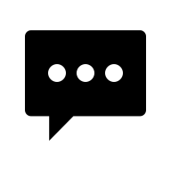
What is LinkedIn?
- Professionals can share who they are and what they do
- Share skills, interests and goals
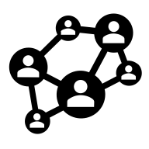
- Connect with people and organisations
- Learn about opportunities

What LinkedIn isn’t
- You don’t share about your whole life
- You don’t post every day
- Not only for paid work

We will talk about how LinkedIn is different from other types of social media.

What does a LinkedIn profile look like?
Types of LinkedIn accounts

- Free accounts:​

- Gives you access to all the basic features
- Premium accounts:​
- You can see who looked at your profile
- You can send messages to people you are not connected to​
- There are more features you can use when searching for jobs


Who uses LinkedIn and why?​

- Workers sharing skills and experience
- People with disability sharing skills and being leaders

- Students and people who have just started their jobs connecting with others​

- Volunteers and people who stand up for rights showing others what they are doing (Volunteering is when you do a task or help out, but do not get paid for it)
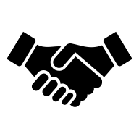
- People who hire workers sharing news and opportunities


When LinkedIn might be useful​
- Share your interests and goals
- Find other people to work with

- Find other paid work and chances to volunteer
- Keep up with news in your field

- Share a project, event or information
- A safer, more professional space than other types of social media


When LinkedIn might not be useful​
- You do not want your profile to be seen by anyone right now
- You do not want to talk to others online about your job

- You get overwhelmed by having too many messages from social media accounts​

- You want to chat to others online about social things rather than professional things

Building your LinkedIn Profile
Create an account
- Go to linkedin.com and click ‘Create an account’

- Enter your email and make a strong password. Save it somewhere safe.​

- Add your name exactly how you want it to be seen on LinkedIn
- Click the link they send you so they can check your email is correct
What is in a profile?
- Photo and headline

- A bit about you (About/ Bio Section)
- Experience, education, volunteering
- Skills and interests
The profile photo
5 tips for a good profile photo​
- Face in clear light
- Simple background
- Have good posture
- Do not use filters
- Wear solid colours
You do not have to put a photo of yourself on LinkedIn if you want to be more private. Instead, your initials will be in place of the photo.

The headline
You can choose different types of headlines depending on what your job is
    - Mission driven: your skills, interests and what you want
      - Good for: People who stand up for rights, volunteers, and community leaders

    - Value Proposition: what you offer, who you offer it to and how you do it
      - Good for: If you are new to LinkedIn or unsure what to write

    - Role and Outcome: What your role is and what you want to get done
      - Good for: showing what impact you want to have rather than just what tasks you do

Activity: Practice writing a headline​

About/ Bio Section
About: What to write​
- Start with who you are and what you care about
- Show what you do (paid, volunteer, standing up for rights, etc).​
- Say your strengths
- Say what you are looking for
- Keep it safe, clear, and real.

Activity: Practice writing a bio​

“I care about (write what your values are)
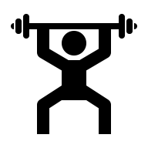
I am working on (what is your role or what projects are you working on?)
My strengths include (3-5 skills)
I am looking for (who do you want to work with or what kind of opportunity do you want?)

Experience section
5 tips for your experience section​
- List roles and projects you have done that have made a good change
- Write what has come from the things you have done
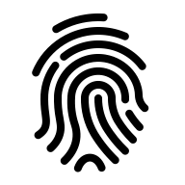
- Show proof where you can
- Add media to back up what you are saying
- Keep it safe and to the point
Activity: Practice writing your experience​
- Step 1: Pick a role or project
- Choose something recent: job, volunteering, advocacy, caring, or study
- Step 2: Note the basics
- Who you helped, what you did, the result and proof that you have done what you are saying
- Step 3: what you have done and who it was for
- Action + for who + result
- Example: I made an Easy Read document for the council workshop. 40 people who got the document said it was easier to use.
Education and training section: Tips​

- Include all learning, not just degrees
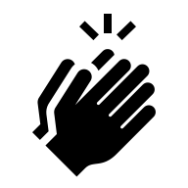
- Keep it short
- Show hands-on skills
- Add proof if you have it
- Include community and library learning
- Keep it safe and to the point

Staying safe on LinkedIn
- Choose who can see your profile
- Hide contact details if you want
- Turn off “share profile updates” while making your profile
- Control who can message you


We will look at how to do different things on LinkedIn, like
- Getting into your settings
- Choosing who can see your profile
- Settings for privacy
- Choosing how you get messages

Protect yourself
- Share only what you are comfortable sharing
- Do not give out too much information about places and when you were there​
- Do not share personal information like your birthday or address

- Ignore, block or report when needed

Who can see your posts, profile, and comments?​
    - Options: only you (draft), connections, followers, the public
    - The more people who can see your post, the more it will get out there
    - Posts in Groups: group members can see it
    - We will go through step by step on how to choose who sees your post

Question: What do you do to make sure you are safe and in control on social media?

Using LinkedIn
- How to connect (step by step)
- People with disability and disability organisations on LinkedIn
- We will talk about things you should and shouldn’t do when writing a post
Question: What could you post about?

Using LinkedIn messaging​
- On a free account, you can message only people who are connected with you
- On a premium account, you can also send “InMail” to people you are not connected with
- You may get messages from people who paid to send them to you. These are called sponsored messages – labeled with ‘Sponsored’.

Keep LinkedIn messages safe and respectful
- Be clear and get permission
- Example: “Hi Sam, I liked your post on accessible events. Do you mind if I ask you a quick question about captions?”​
- Let others know what you want and keep it professional
- Example: “Thanks for the info. I think I have everything I need. Thank you for your time.”​
- Protect privacy and safety
- Example: “I am not comfortable sharing that. I will end the conversation here.”
LinkedIn accessibility features​
- Screen reader support on core tasks
- Alt text for images (reads out what the image is)
- Captions for video
- Live visual assistance
Finding job opportunities
- step-by-step how to
Learning opportunities: LinkedIn Learning​
- Many different courses
- You can try it for free for 1 month
- LinkedIn Learning may be free with a public library card – check with your library

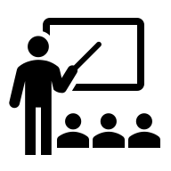
Wrap up and next steps
- What did we cover?​
- We will email you the recording of this workshop
- You can find slides and resources on the JFA Purple Orange website
There are more free workshops coming up
28 January:​ Practice, film and edit your own vox pop (in-person, Unley)​
30 January:​ Get your professional photo taken (in-person, Unley)

Do you have any other questions? You can

Email: media@juliafarr.org.au
Call: 08 8373 8388

