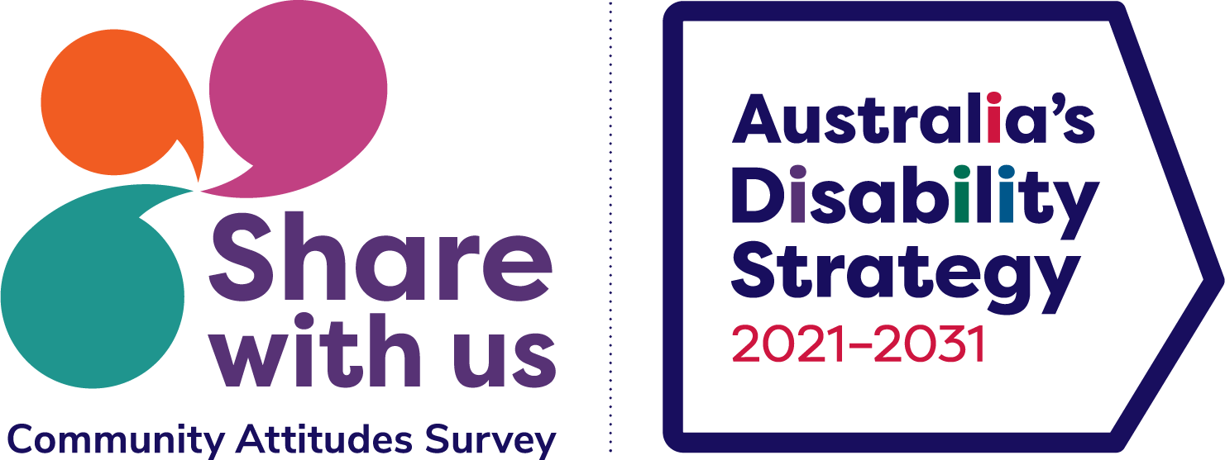

Disability Attitudes Study Information Sheet



There is a new study. It is with
Purple Orange
Australian National University


The study is about Australia’s Disability Strategy.
This is a plan is to help people living with disability.



The study is being done for the Government.


We are inviting you to be part of a group to talk about disability and attitudes.



The group will talk
Online
In person.

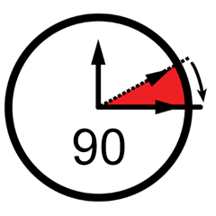
We will talk for about 90 minutes, up to 2 hours.
You can leave at any time.


We will give you a $60 gift card to thank you for talking with us.

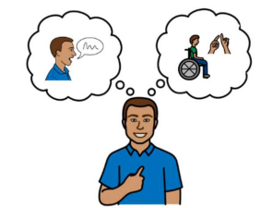
We want to hear stories about how people’s attitudes impact you.


The stories you give us will be used in a report for the Australian Government.


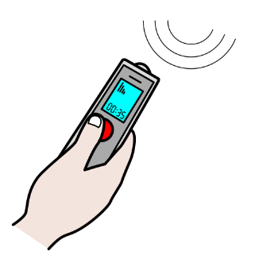
If it is ok with you, we will record what you say. We can record your voice or write notes.

We will keep your information private.


There are rules that tell us how to keep your information private



- We will not share your name.
- When the project is finished we get rid of your story.

- You can ask us what information we have about you whenever you like
- You can ask us how we keep your information private.


You may feel bad/sad telling your story or hearing other peoples’ stories. Other people in the group will hear you tell your story.


You can tell us if you feel bad/sad and if you would like some help. We can arrange some support.


It is ok to leave the study.
Tell us if you do not want to be part of this study. If you leave, or if you want your data to be removed, what you have said will be removed as much as possible.


Contact:
Purple Orange
(08) 8373 8388


Purple Orange admin@purpleorange.org.au


If you have any questions, worries or need help, you can contact:

Purple Orange
(08) 8373 8388

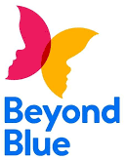
BeyondBlue
1300 22 4636


Lifeline
13 11 14



Ethics Committee Approval

This study has rules
These rules are called ethics.

The ethical aspects of this research have been approved by the ANU Human Research Ethics Committee (Protocol 2022/467).


You can ask questions about the study, or
You can complain if you did not like some parts.

Contact:
Ethics Manager
The ANU Human Research Ethics Committee

(02) 6125 3427

Human.Ethics.Officer@anu.edu.au


We used pictures from
Noun project
Boardmaker
Microsoft Icons
Open Symbol
ARASAAC

